**LAB 7. THREE LAYER MODEL**

**Exercise 1.** Given Internship Management database like the Lab 2:

* Students (student ID, full name, hometown, date of birth, GPA):
* Project (Project ID, Project name, Supervisor, funding)
* Student_Project (student ID, Project ID, internship place, distance, results)

**Theoretical summary:**

* **Data Access Layer:** is basically the server which stores all the application’s data. Data Layer contents Database Tables, XML Files and other means of storing Application Data.
* **Business Layer:** is mainly working as the bridge between Data Layer and Presentation Layer. All the Data passes through the Business Layer before passing to the Presentation Layer.
* **Presentation (GUI) Layer:** is the Layer in which the users interact with an application. Presentation Layer contents Shared UI code, Code Behind and Designers used to represent information to user.

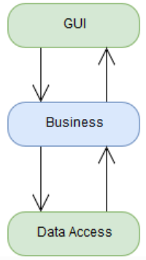

***Use the 3-layer model to implement the following requirements:***

1. **Design the Student management form as follows:**

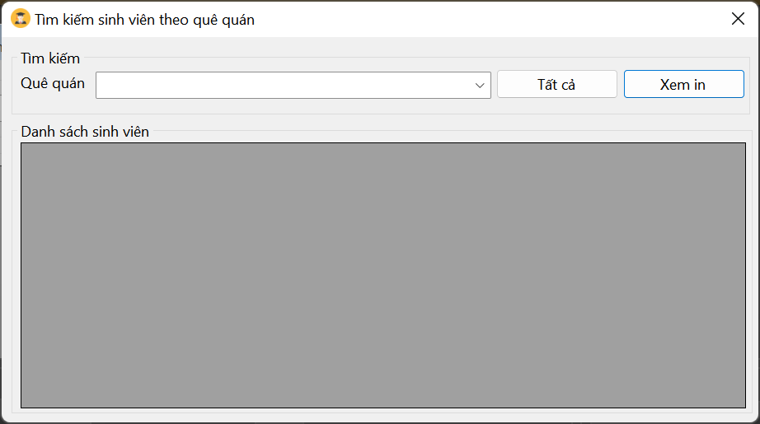

* Formload event:
  + Show Student list on gridview
  + Controls in Student Information are disabled
  + Hometown: Contains provinces: Saigon, Thanh Hoa, Nghe An, Long An, Quang Ngai, ....
  + Delete, Edit, Save buttons are disabled
* When the “Add” button is pressed:
  + Controls in student information are enabled.
  + Clean up the textboxes
  + Student ID textbox is focused.
  + GPA only allows entering numbers
  + “Save” button is enabled.
* When “Cancel” button is pressed: same as formload event.
* When clicking to select a row in gridview:
  + Selected data will be displayed on Student Information
  + Edit and Delete buttons are enabled.
* When the “Delete” button is pressed:
  + Confirm “Do you want to delete this student?”,
  + If you choose Yes:
    - Delete data in Student table
    - Update gridview
* When the “Edit” button is pressed:
  + Allows to edit information in Student Information except Student ID information
  + “Save” button is enabled.
  + Textbox full name in focus.
* When the “Save” button is selected:
  + Check if adding data or editing data
  + Update data to Student tabl
  + Update data to gridview.
  + Status like formload event.
* “Print PreView” button: Allows printing the list of students (self-study).

1. **Design the Project management form.**

Design form and handle similar to Student Management Form.

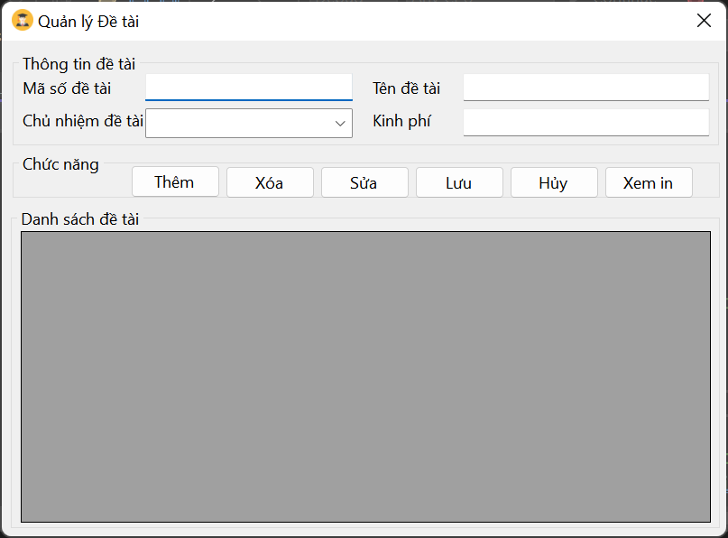

1. **Design the form to manage internship results: Do it yourself according to the form above.**